**APCSP Activity 1.3.8: While Loops**

Learning Target: Define the problem and analyze research to create a solution to a problem.

**Step 8**

Define a function goguess() that implements a number guessing game as described below. Strategize as pair programmers. Then iteratively code and test.

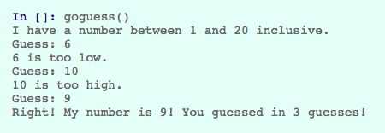

|  |
| --- |
| def goguess():  answer = random.randint(1, 20)  guess = 0;  total = 0;  print('I have a number between 1 and 20 inclusive.')  while (answer != guess):  total += 1  guess = int(raw_input('Guess: '))  if (guess < answer):  print(str(guess) + ' is too low.')  elif (guess > answer):  print(str(guess) + ' is too high.')  elif (guess == answer):  print('Right! My number is ' + str(guess) +  '! You guessed in ' + str(total) + ' guesses!') |

**Step 10**

What is sorting?

Sorting is a computer algorithm that’s designed to organize a set of data so it’s easily queryable/presentable.

What are the different sorting algorithms used in computer programming?

* Insertion
* Selection
* Bubble
* Shell
* Merge
* Heap
* Quick
* Quick3

Which sorting algorithm is fasted in the following situations?

|  |  |
| --- | --- |
| **Data** | **Fastest Sorting Algorithm** |
| Random | Heap |
| Nearly Sorted | Insertion |
| Reversed | Heap |
| Few Unique | Quick3 |

**Conclusion Questions**

1. Write a while loop that will count from 1 to 100.

|  |
| --- |
| x = 0 while (x < 100):  X += 1  print(x) |

Write a for loop that will count from 1 to 100.

|  |
| --- |
| for x in range(100):  print(x + 1) |

2. Describe the difference between a while loop and a for loop. When is it appropriate to use each?

A while loop is only used when you want to repeat a task until certain conditions are met which would be used in video game logic, as you can make certain events happen depending on the current state of the game. A for loop is used for looping through an array of data which would be handy for database management or just anything that uses an undefinitive amount of data.